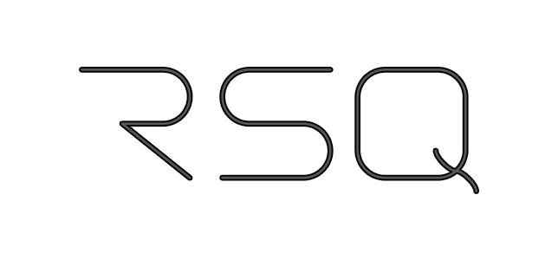

**Tethered Over-scene Camera (TOC)**

Quicklook Assessment Report

|  |
| --- |
| Abdullah AlMuhaideb, Ademide Ajose, Pratik Vijay Toshniwal, Praveen Kumar Venkatesan, Sandheep Sridar |

# **Executive Summary**

Our team performed a quick look assessment on the use of unmanned aerial systems that promote safety, efficiency and protection through accurate fact collection for America’s emergency responders, law enforcement officers, homeland security agents, and any other official with a badge, and the public they serve. The specific technology in question is a Tethered Over-scene camera (TOC), a device that comprises of a tethered quadcopter UAS equipped with multiple cameras which can be fitted on the LED light bar on a vehicle’s roof. Effective usage of the TOC can save millions of dollars otherwise spent in traffic incidents, settlements and court judgments in police misconduct.

**Market and Market Segments**

In order to understand the potential for the TOC, out team conducted numerous interviews with the inventors, potential licensees, future customers and the general public. Our research yielded the use of the Tethered Over-scene Camera among the first responder communities. Once we identified the potential customers, we realized that the State Departments of Public Safety (DPS) would be the key market segments.

**Market Interest**

In order to understand the market interest, we spoke with one of the potential customers of RSQ systems – a lieutenant at College Station’s police department. He described the market for the technology as still in its infancy. He felt that adoption might be slow but that the need for the technology can grow with time. This description is not unheard of for a technology of this sort, especially when introducing a new way to approach a problem.

**Barriers to Market Entry**

There are several barriers that could impact the ability to commercialize this technology. These include:

* Existing Drone programs employed by the DPS which could prove a hindrance to the adoption of the TOC
* Privacy concern - FAA regulation imposes strict rules on the deployment of drones over private properties
* The Time to Production for a single unit of the TOC is not known. Manufacturing the product at scale is a hurdle for which a solution has not been identified
* Integration of the surveillance feed with the AXON Evidence portal to maintain a single repository of data
* The product has not been user tested. It is still in its early stages of development and they might still find gaping issues upon testing

**Development Status of Technology**

TOC has passed the concept stage and multiple patents have been filed but are awaiting approval. The first prototype has already been designed and developed. Also, the functional prototype has been developed. RSQ systems plans to initiate a pilot program by providing the TOC to the Texas A&M University campus police force.

**Recommendation**

Based on the information the team gathered from primary and secondary sources, we believe that there are no direct competitors to the TOC. The technology is intended to be easy to use and accessible to any first responder to better assess the situation and help in keeping the community safe. The team recommends that the inventors introduce the product to first responders as soon as possible as we believe the positives obtained from this early release would help solidify the viability and necessity of the TOC. In conclusion, our final recommendation is that this product be commercialized with the prime motive being to license this technology to existing players in the market who have a strong grasp over the field and can help bridge the gap that exists in the product.

**Table of Contents**

**Executive Summary** **2**

**Technology Description** **5**

**RSQ Systems Company’s Background** **7**

**Development Status of Technology** **7**

**Patent Status of Technology** **8**

**Potential Benefits and Drawbacks** **9**

**Market Interest and Potential Commercial Markets** **10**

**Future Scope of Technology** **11**

**Competing Technologies and Competitors** **11**

**Barriers to Entry** **12**

**Recommendation** **13**

**Appendix** **14**

# 

# **Technology Description**

RSQ-Systems develops 360 degree aerial view tethered drone for safety and security. They have named it Tethered Over-scene Camera (TOC) which provides an aerial, fixed-position high quality view of the surrounding area. This device helps promote safety and provides protection by collecting factual real-time information for law enforcement officers, police, public safety officers, and homeland security agents. The device is innovative and cost effective.

The device consists of multiple cameras, tethered, quadcopter UAS which can be fitted on the LED light bar on a vehicle’s roof. The device can be activated from inside a vehicle’s dashboard using a remote, a smart holster and the TOC lifts to a height of 35 feet vertically. Once the device reaches the 35 feet height, the four cameras on the device starts recording the 360 degree view of the intervention scene around the vehicle.

The Ethernet cable that connects the device to the vehicle abides by the current legal requirements. 35 feet is within the limit to which a camera equipped device is allowed to rise. The device is powered via the vehicle battery. The data in the device can be downloaded to a local storage device present in the vehicle at a very fast speed. And for the ease of use, the device is triggered by holster or remote controlled.

**Prototype:**

Design “bird” Evolution

These images shows the incremental changes in the design of the bird

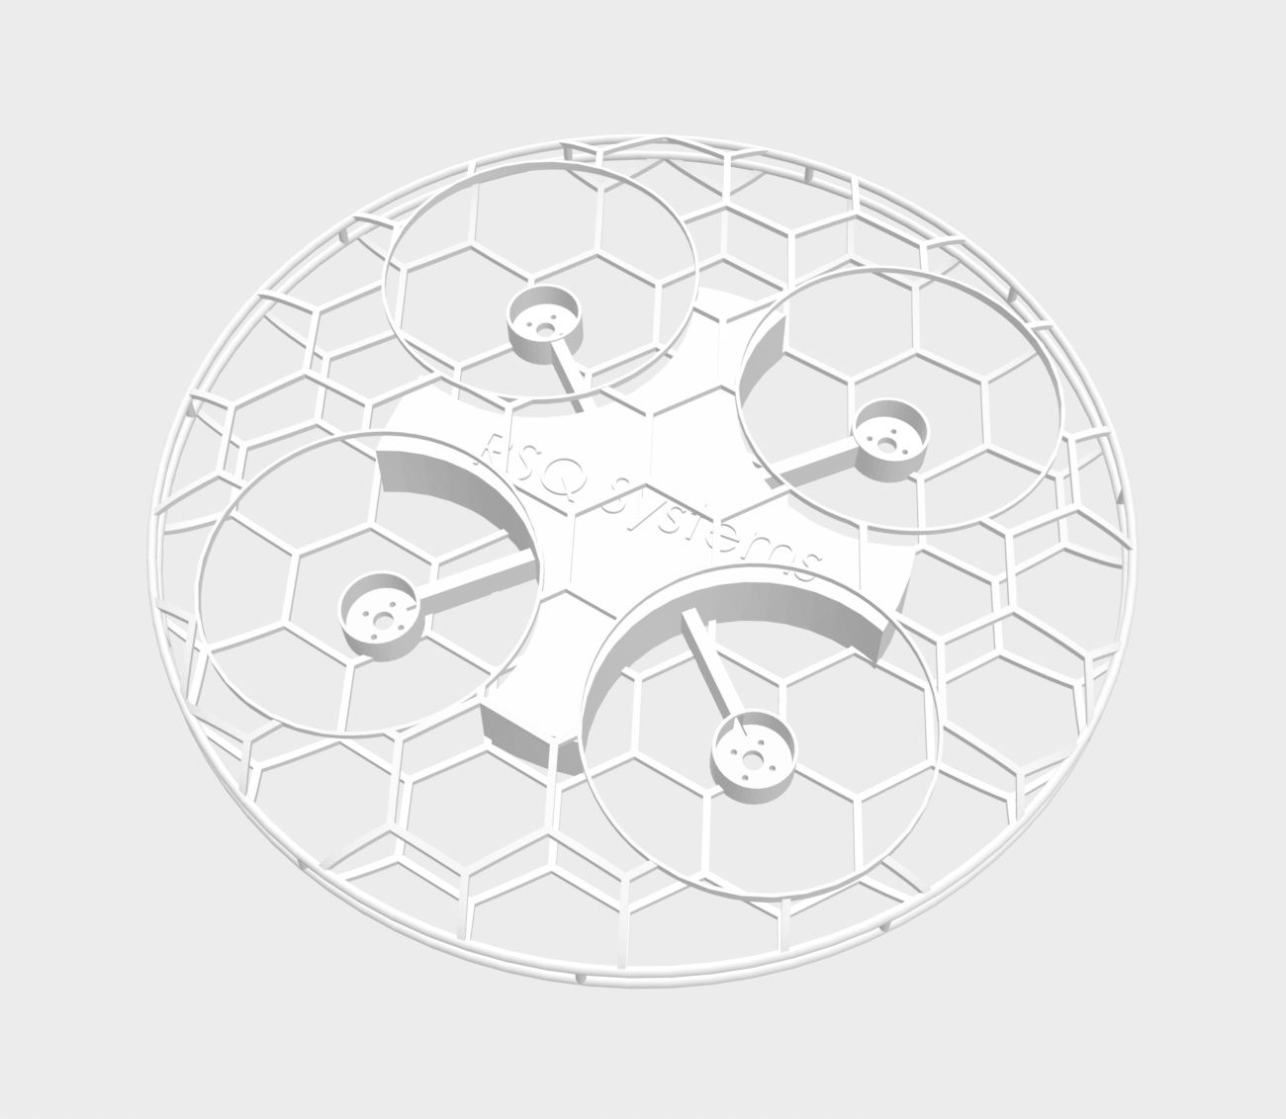

Fig1. The incremental changes in the design of the bird

**Casing:**

The design of the casing which protects the bird and from which the bird is deployed

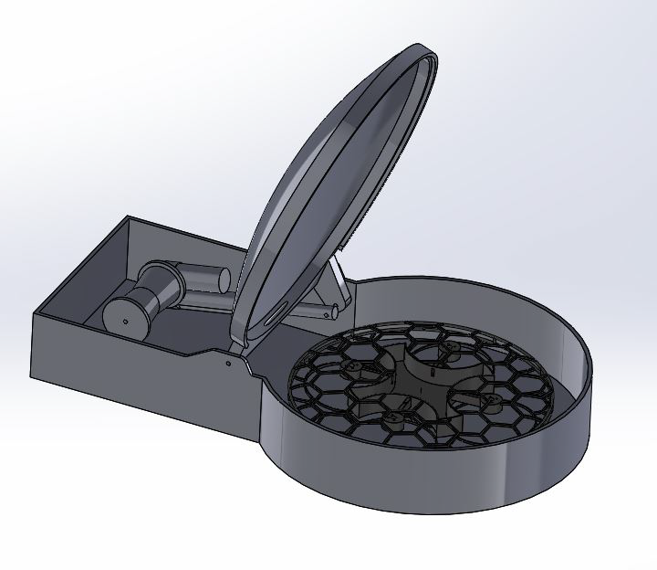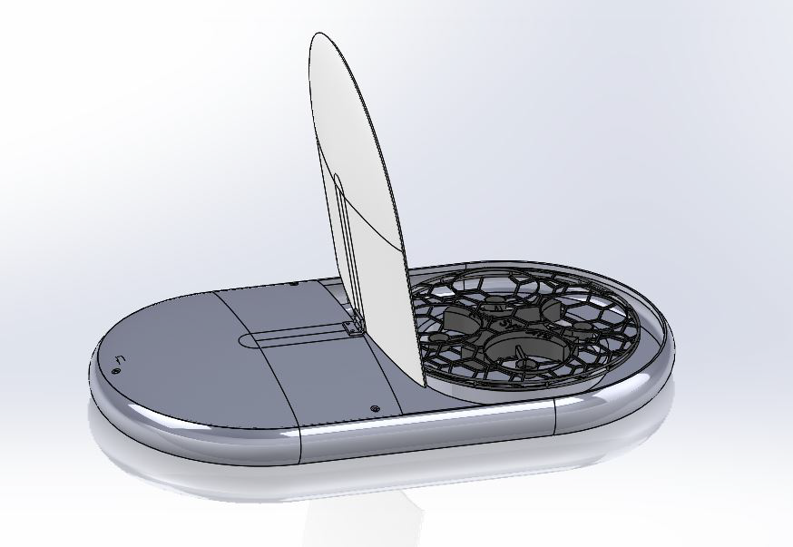

Fig.2 The design of the casing

**Top View:**

This is a top view of the bird and the honeycomb design is to enhance the balance in the air

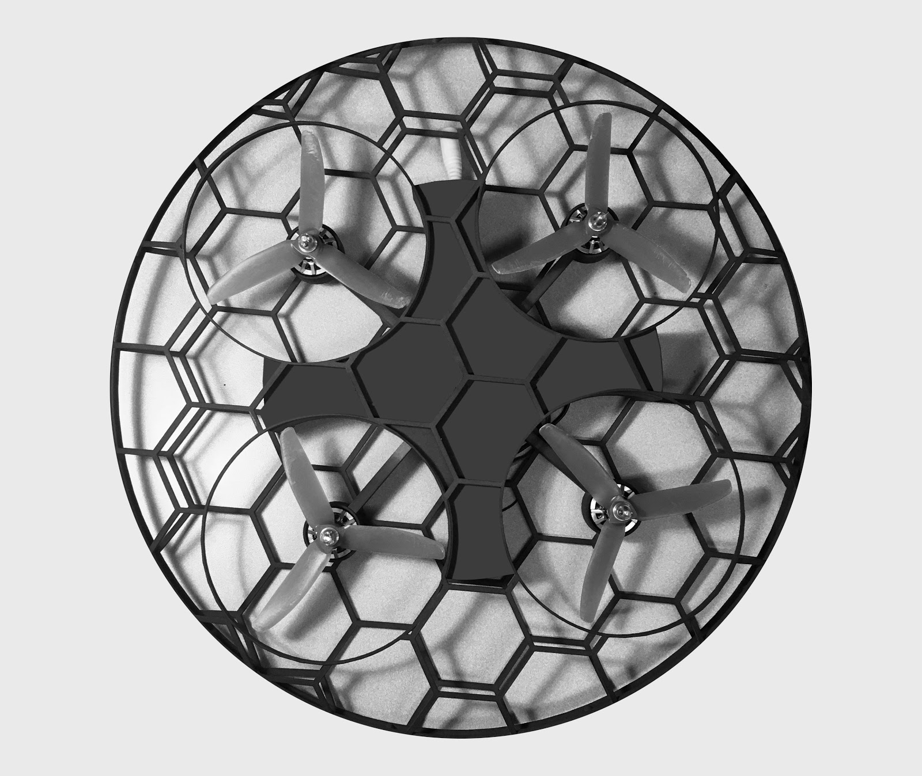

**Device Tethered to a Vehicle:**

This image shows how a deployed bird looks like on a vehicle

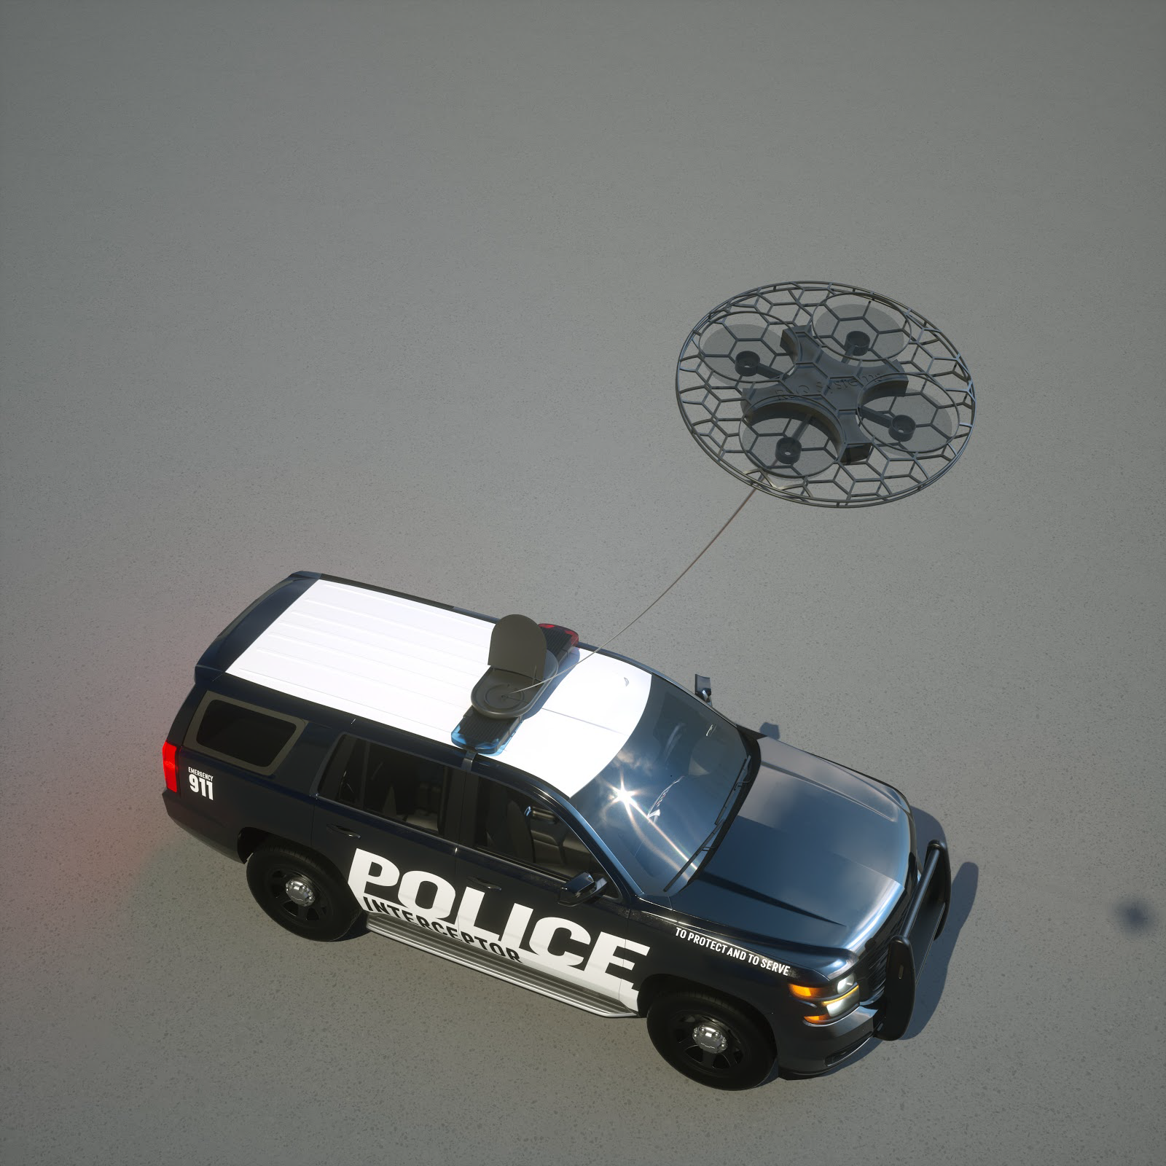

Fig.4 Tether Design

Fig.3 Top view of the bird

**View from the Camera:**

This is a view captured from the bird which is deployed on the vehicle

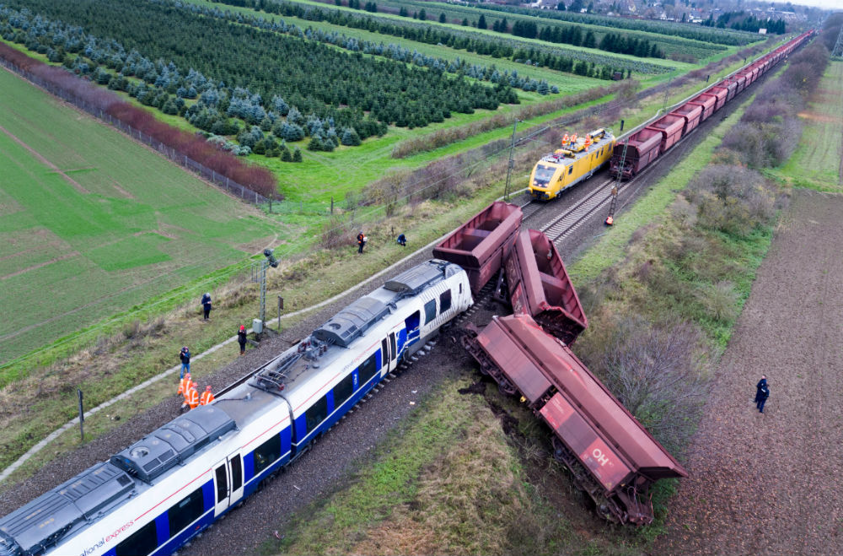

Fig.5 Expected view of the camera

# **RSQ Systems Company’s Background**

RSQ started with two inventors who have two different backgrounds. Mathieu Buyse is coming from the photography and cinema industry and he was working as a photo director. On the other hand, his co-founder has a military background. After the attacks in Europe, they brainstormed for a good use of drones to help in public safety. At that time, most drones usage was recreational or in the cinema industry. According to Mr. Buyse, they had an original idea that is confidential at the moment. After further research, they found that Europe’s law enforcements are still behind in using technologies that involved cameras usage such as body cams. They were only using limited dash cams. As a result, they realized that the market is in the US and switched to the US market. RSQ systems started in an incubator in Belgium called “Wallonia Export-Investment Agency (WEIA). Through the partnership between WEIA and Texas A&M University, the company started the collaboration with different entities in US. RSQ has been organized in the US since January 2018. “RSQ label itself as concept development creator not a manufacturer” said Mr. Buyse.

# **Development Status of Technology**

RSQ systems started working on a technology which is confidential at the moment for 18 months. However, after listening to its partners they switched to Tethered Over-scene Camera (TOC).

TOC has passed the concept stage and many patents were filed. Mr. Caleb Holt the former product development center’s manager at Texas A&M shared with us the journey of the product development. According to Mr. Holt, in 2017 TOC was a concept and Mr. Buyse was working with a lab at Texas A&M to develop a prototype of the bird which is the part that fly. Mr. Holt, on the other hand, was working on the enclosure (casing) which is the part that is attached to the car. By March 2018 RSQ participated in Fire Response Innovation Showdown at Texas A&M and with the first prototype “*Many modifications were done after that competition*,” said Mr. Holt. Three different groups were working on the development of the product and by winter 2018 the functional prototype with the modifications was ready. As a result, the proof of concept was reached. “The solution is now 85 % ready” said Mr. Holt.

According to Mr. Buyse, RSQ is in a discussion with COBAN which is one of the leading American manufacturers for law enforcement cameras to be the vendor for 360 cameras. “*RSQ wants the product to be 100% American made. I believe that any product that is used by American law enforcement should be made in the USA*” said Mr. Buyse. DJI drones which is Chinese company had issues when it wanted to enter the law enforcement market since it wasn’t made in the USA.

Mr. Buyse has shared that RSQ is in the final stages of licensing the product for an entity in the United States. The plan is to use 3D printing to manufacture the product with a carbon fiber which is durable and light and great in avoiding electrostatic.

# **Patent Status of Technology**

RSQ has filed for three utility application patents in mid-2018. These patents are:

* 9002 “Vehicle-Based Deployment of a Tethered Surveillance Drone”. (US 16/046,721 Pending)
* 9003 “Tethered Drone System with Surveillance Data Management” (US 16/046,691 Pending)

This patent is the most important one and RSQ just got the approval on the expedite process for it. The reason behind this according to Mr. Buyse is that AXON which is the largest provider for US law enforcement body cams is doing some work in the domain of data management and RSQ would like to be there first.

* 9004 “Stability Systems for Tethered Unmanned Aerial Vehicles” (US 15/912,130 Pending)

There are two other patents that are still under development which are 9005 “Tracking Systems for Tethered Unmanned Aerial Vehicles” and 9006 “Illumination for Tethered Unmanned Aerial Vehicle”.

Ms. Wei Wan from the tech commercialization office at Texas A&M commented on the time to start licensing the product by saying “*as soon as you file the patent”*. The patent’s 20 years exclusive rights will start from the earliest filing date. That is why it is important to start looking for potential licensees even if the patent has not been granted yet.

# **Potential Benefits and Drawbacks**

In order to assess the product better the potential benefits and drawbacks have to be analyzed.

Following are some of the benefits of the Tethered over-scene camera:

1. **Originality of the Crime Scene**

When a College station K9 officer was interviewed about his views on this product, the first thing he pointed out was that such a device would help the officers preserve the originality of the crime scene.

*“The second I walk into a crime scene I've changed the crime scene whether intentional or unintentional simply that if you know that car over there was part of a crime scene the second I walk up there something has been altered so with this it's got a video of all the way around showing that OK this is what happened when I walked up there this is not this is what it looked like prior to me going in there”*

1. **Can be quickly adopted seamlessly**

When a product which helps supplement critical day-to-day activities, it has to be user-friendly and more importantly it should not hinder the daily routine of the users. Since there is no need for a battery, the TOC can record for long periods of time which gives the officers a lot of flexibility and allows them to focus on the scene of the crime. Also it doesn't require any pilot certification or training for the person who is going to use it since it is tethered.

1. **360 degree View**

Lack of proper video evidence has led to either criminals escaping or innocents being charged. The 360 degree view captured by the TOC will definitely add context to existing recording devices such as dash cams and body cams which record in just one perspective.

Following are some of the drawbacks of the Tethered over-scene camera:

1. **Durability of the Product**

Even though this product is mounted on an officer’s car, it is important that the product is able to sustain certain external factors. The officer interviewed mentioned a valid point about the product being able to sustain a simple car wash. However, the co-founder maintained that they have not started fine tuning the product yet and it will be done in future iterations.

1. **Security Constraints**

The co-founder mentions cost savings on litigation/lawsuits as one of the advantages. However, inefficient security measures or lack of it could have an impact on how the evidence is considered. For example, the body cam manufacturers have processes to save the video securely in the cloud which makes the footage to be credible.

1. **Lack of data transmission**

In the current working model, the footage being recorded is stored locally in the car. The data being recorded will be even more useful if it is transmitted back to the command center. Storing videos locally leads to security issues and the IT team has to frequently check on the storage remaining. When asked about the drawbacks, the co-founder acknowledged that lack of data transmission is certainly an issue. Furthermore, the K9 officer interviewed told us that he would like data recorded from such a product to have live relaying of data.

# **Market Interest and Potential Commercial Markets**

In evaluating the interest for this product, we decided to use a three-step process:

1. Market Identification

2. Market Understanding

3. Market Evaluation

**Market Identification**

In market identification, we employed Google’s Ad service to understand the size of the market RSQ systems is in. We found that, on a monthly basis, there are over 50,000 searches made that look for services provided by (or similar to those provided by) RSQ systems.

**Market Understanding**

To understand the market RSQ is in, I spoke with one of the potential customers of RSQ systems – a lieutenant at College Station’s police department. He described the market for the technology as still in its infancy. He felt that adoption might be slow but that the need for the technology can grow with time. This description is not unheard of for a technology of this sort, especially when introducing a new way to approach a problem.

There appears to be a second segment of people who go into the wildlife with trucks to explore wild animals. A student I interviewed loved the idea of the technology which would be tethered to the car used for driving through the jungle as the employ multiple views of admiring nature. The added value of an aerial view was something he described as “appealing”. When asked if this added view to the whole wildlife experience could lead him to pay extra during his excursions, he responded by saying “I am not very sure, it depends on how much”.

**Market Evaluation**

From the work done, we see that the market is not mature and is still in its growth phase. The interview with the lieutenant and the student informed a level of optimism for the market. It is still left to be seen if this enthusiasm for the technology is sufficient enough to make these groups of people purchase the technology.

# **Future Scope of Technology**

The TOC device does not face any legal challenges to enter the market and has a working model which improves the safety of the public and helps law enforcement officers. As per the company estimation, they have identified their market and has done some research and have some numbers.

As per the company, they are planning on selling or licensing the technology to a potential manufacturer who will take care of manufacturing, distribution and selling the technology. The company will either sell the technology receiving a onetime payment or they will license the technology once the design is ready and will receive a royalty from the company who purchases the license.

As of now the focus for the technology is first responders. But in future they are going to target defense companies, insurance companies, inter-state truckers and road workers companies. As well, they plan to partner with companies who manufactures the cameras for cars so that they can rely on their expertise and give customers more confidence in their design and product. They also plan to transfer the footage captured using the first responders network provided by companies like Verizon. The first responders’ network is a separate reliable network which is not accessed by the public and it works even during high network usage like New Year’s Eve or some disasters. Thus giving them preference and making the footage useful in times of distress.

The company is targeting defense and first responder in the USA and thus they want to tag their product as ‘Made in USA’. Which is why they will not source parts or outsource work to other countries where manufacturing cost would reduce drastically. This will give their customers confidence in their product and not worry about tampering with the product.

# **Competing Technologies and Competitors**

There are a lot of companies in the US which are competing in the law enforcement camera technology market. Some of the major players in the US market include Aventura, Black Mamba, BrickHouse Security, Brimtek, COBAN. Many police departments use body-worn cameras made by Axon (formerly Taser), which provides free cameras and sells data storage services. Each of the above companies listed above have their own flavor and interpretation. For example, FlyWIRE cameras develop cameras for underwater surveillance.

The most notable tethered drone camera in the market isElistair drones[1]. They have a wide variety of drones with amazing streaming technologies. The only difference is that they are not mounting the drones on vehicle. Instead, they are selling the drones in boxes which can be opened at a certain location and deployed. The target market for this product includes military, crowd control and civilian traffic control. More importantly, they are a France based company and do not have an existing customer base in the US market.

Hover fly tech is a company which is developing tethered drones similar to TOC. The drones from Hoverfly tech are tethered to buildings and not on moving vehicles and so it is difficult to compare both products because of several reasons. When a drone is tethered to a building it can be protected by sophisticated materials and there is a lot of room for design innovation which is not possible in a car.

Some noteworthy mentions in the tethered drone market areFoxtech drones[2],xd-motion[3]. While these companies are offering similar technology, the TOC is different from these products because they are comparatively cheaper and they are developing technology to mount these drones on cars and not sell them as a separate device.

# **Barriers to Entry**

Existing Drone programs employed by the Public Safety Departments could render adopting the TOC superfluous. As per a new article dated Feb 21, 2018 the Texas Department of Public Safety (DPS) has a running drone program that is being used for crash scene reconstruction[4]. While the program was started initially in 2008, it was scrapped off owing to challenges posed by federal restrictions and maintenance costs. But in recent years, the advancement in technology has helped fight the case and Department of Safety has invested heavily to adopt the drone program. Given that the program has been adopted in recent years, it might cause a hindrance to the adoption of the TOC for the same use case.

The manufacture and sale at scale for this technology might seem a difficult prospect for a new entrant but if the upsides of the technology are emphasized and a potentially large company takes over the product, then the chances are higher for the product to have a good reach. As mentioned by Mr. Buyse, the production of the product on a massive scale is a reason for worry. In the words of Mr. Buyse even with the use of a 3d printer to develop molds for the outer casing(shell) of the TOC to fasten the production, the time required for the integration of the cameras and the drone with the system is expected to be high.

Axon is officially partnered with the law enforcement department in supplying body cams and dash cams. The surveillance feed from these cameras is synced for later viewing using a cloud technology that Axon provides, called Axon Evidence. Ideally, the feed obtained from the TOC is expected to be synced into the same system. Mr. Buyse explained that they would ideally integrate the TOC feed with Axon Evidence. While this is the proposed plan for TOC, there is no hard evidence suggesting that this integration is feasible.

Also the current status of development of the technology is a working prototype but one that hasn’t been user tested[5]. As per the words of Mr. Buyse, they have designed the prototype getting key inputs and insights from First Responders. Although the specification would align with the requirements of first responders, the product needs to be user tested before it can be commercialized. The company that adopts this technology in the future would have to take the testing in their own hands. Testing is costly and time consuming but is necessary in order to prove to customers that the technology is trustworthy.

# **Recommendation**

Based on the information the team gathered from primary and secondary sources, we believe that there are no direct competitors to the TOC. The technology is intended to be easy accessible tool to the first responders to help them in keeping the community safe. Also, it would help in a better assessment of the situation if there is any police misconduct reported in an incident that lead to court. This may save millions of dollars in settlements. TOC can help in traffic by providing a holistic, comprehensive and factual view of an intervention scene. As per our understanding from the research, the TOC would not directly compete with any preexisting technology but in principle complement them.

The team recommends that the inventors introduce the product to first responders as soon as possible as we believe the positives obtained from this early release would help solidify the viability and necessity of the TOC. In conclusion, our final recommendation is that this product be commercialized with the prime motive being to license this technology to existing players in the market who have a strong grasp over the field and can help bridge the gap that exists in the product.

A company that has proven expertise in aiding law enforcement, being financially capable of manufacturing the product at scale and having experience in carrying out testing for the product would be an ideal candidate to license the product. This potential licensee would ideally assume onus on the manufacturing, testing and distribution of the TOC. Given the futuristic vision of the TOC and the millions of first respondents it could serve, the company that licenses the product would gain a stronghold of the market.

# **Appendix**

**Ms. Wei Wan (Licensing Associate at Texas A&M Tech Commercialization) phone call (Oct 10 2019)**

**When can we start licensing the technology?**

Licensing process can start as soon as you file for the patent. You should never wait until your patent is granted. The patenting process may take between 1 to 10 years depending on the technology. Also, you have to remember that the 20 years patent protection starts from the earliest filing date.

**Can we have multiple licensees?**

You can have the option between exclusive rights to one licensee or have multiple. This depends on the nature of the technology. For example the lower value technology usually can be licensed for multiple licensees. Also, you can have the exclusivity in the territory like one licensee for the US and another in Canada.

**What is the procedure to license the technology?**

If the technology is from TEEX, then the licensing will be through the tech commercialization department. All the negotiation and the agreement will be through us. Then, the approval would come from Mr. Cornwell. After that, the final approval is from the general council of the university.

**Summary of Zoom Meeting with Mr. Mathieu Buyse (Co-Founder and CEO of RSQ Systems) (Oct 9 2019)**

**How did you start the company, and why?**

Two reasons lead us to start the company:

1- I have a Photography background (photo director) and used lots of drones. The co-founder has military background so we combined our backgrounds to come up with this technology.

2-The drones can be used to help people not only in taking pictures and video for pleasure. After Brainstorming and mixing of ideas. We thought this idea can have a real impact on the society. To have images in the dangerous seen. The police have asked the people to send the photos that they have after the terrorist attack in Belgium.

After studying the market, we saw that Europe is not our goal since they are behind in using camera related technologies and the US would be our market.

**What are the development phases for the product since July 2016?**

The project has changed from its original idea. Now we are at the end of the prototype phase. We are heading to the technology transfer to commercial project. RSQ is a concept development creator not a manufacturer. As a result we would like to license the technology and we are in the final stages of doing so.

What is the status of the parent company in Belgium? Does it have any commercial product?

It is still running and has a big part in the engineering. We also kept it running since we have a partnership with very big European companies.

**How many employees does the company have?**

We don’t have any employee except the CTO since we are in the beginning. Once we see the business model is real we can hire people.

**Have you installed any unit in Texas A&M Police vehicle?**

No we haven’t. We had some delays and we are expecting to install in 6-9 months.

**What is the patent status of the technology?**

Still pending. We are trying to prioritize 9003 which is about data management. AXON which has 90% of the law enforcement body cam market is also working in the data management. So we are trying not to have the monopoly. We have just got the grant to expedite this application.

We are also trying to do it internationally that is why it is complicated.

**Do you have any comment on the privacy concerns on the technology?**

I don’t know what the policy is. In Europe, privacy is not the same for police. We haven't had any issue regarding the privacy concerns.

Also, you have to know that rules are not there not to be changed if there is something that needed correction.

**Is there any documentation for the 30 ft. height that doesn’t need FAA approval and can this change?**

Our goal was to remove all the regulation for the remotely controlled drones. We can’t avoid all the rules but there are still a few left.

**Summary of phone call with Mr. Caleb Holt (Former Product Development Manager at Texas A&M and CEO of AXEL-BOX)) (Oct 14 2019)**

**Can you take me through the phases of the project?**

Started in 2017 RSQ was a conceptual idea. There was a potential and the original idea was changed to Tethered system. At that time Mathieu was working with a lab on campus to develop a prototype. I was working with my team to design an enclosure. Another team was working on the tethered system. Because of the competition that was held in Texas A&M the work was expedited and by March 2018, the first prototype was ready. It wasn’t perfect but it was working. Many modifications and changes was done after that and the enclosure went to a different path.

It is important to note that any change that exceed 0.25 inch would create a change in the whole system. Since there were three disconnected groups working simultaneously the engineering team in Belgium, My team and Mathieu’s team it was important to coordinate.

We learned from the first prototype that the bird needed a stronger tethered system for harsh environment. In winter 2018, we receive the functional prototype. Now, we have an 85 % solution ready.

It took two years to build this system and all the three components which are the Bird, Enclosure and tethered system are in the design free phase. As you know, all new startups needs funds and RSQ reached to the point that more funds are needed and that is why a licensing opportunity is being pursued

**Did you face any issue regarding the regulations?**

Most regulations are for the Unmanned Aerial System. They are sealed by the 300 ft. height and the pilot need to have training. They also require unmanned certificate of operation authorization

The biggest advantage that RSQ systems has is not the 30 ft. height but the fact that it is tethered.

**Was there any privacy concern?**

No one told us anything wrong with the privacy including the FAA.

**Mr. Colby Story (Firefighter at Station 6 in College Station) in-person meeting (Oct 14 2019)**

**Do you take photos of the fire scene?**

Yes and no. There is an investigator who would take photos of the location after we put the fire off and in might not be instant. It depends on the working schedule.

**Do you wear a bodycam?**

No

**Does the fire truck have a dash-cam?**

No

**If an incident happened do you rely on eyewitnesses only?**

We have many procedures and precautions that we use to prevent any incidents from happening. Such as the Current Situation, Action, Need (CAN) which helps the firefighter to ask for help in any dangerous situation. We also have alarms that detect motion that we carry with us.

**Do you use drones?**

Yes, we have a unit and a pilot that can fly it. We usually use it in large spaces like shopping malls or in case of wildfires

**Can you see a usage of TOC in your department?**

It all goes down to the cost and the need. We have a ladder that can be extended to more than 80 ft. that can give us a bird view of the location and we don’t tend to take photos from that height.

**Summary of a phone call with Dr. David Breeding Unmanned Aerial Systems coordinator at Texas A&M University (Oct 14 2019)**

**Does the tethered drones have the same laws as the UAS?**

No, actually there is a specific section excluding the tethered drones from the FAA regulations. It is Part 107 in title 14. Also you should note that the general safety regulations should be satisfied.

**Note**: upon referring to the title and section there was no mentioning of the exclusion but there was H.R.302 - FAA Reauthorization Act of 2018 that exclude the tethered drones from FAA regulations.

**Summary of In Person Meeting with Mr. Mathieu Buyse (Co-Founder and CEO of RSQ Systems) (Oct 10 2019)**

**What are some of the initial challenges that you faced while developing the TOC prototype?**

I believe that Design can avoid a lot of questions regarding standards and the type of material used. We worked on multiple iterations on the shape of the outer casing to shield the propeller against wind gust, we finalized on the honeycomb which helps with air flow while also providing a protective structure around it.

**What are some of the Potential Benefits that TOC provides? How different is it as compared to Bodycams or Dash-cams?**

There are a number of benefits that the TOC provides but the top ones would be

1. No special Drone team required for operating the device
2. Providing complete view of any intervention - Dash cams and body cams capture only a single point of view while our product would capture a 360 deg view. This helps in providing a thorough assessment of a given situation.
3. Data for claims and trials - The surveillance captured by the TOC would ideally supplement any other information captured and could serve as proof during a trial.
4. Improvement of procedures - The captured feed can help in understanding the fallacies of existing procedures and help with identifying procedures which help the investigation and also increasing the safety of the first respondent.
5. Training
6. Statistical Data Analysis

**Did you consider weather conditions and what measures did you take the durability of the product?**

I don't know because, it has to be decided during the product development phase. As of now, we just have a functional prototype.

**What are your plans for low light conditions?**

Of course that is a problem, the goal is to have cameras with high sensitivity and it should be able to capture good quality footage. The solution we have as of now is to have powerful flashlights attached to the cameras to increase visibility.

**What was the result of your competition research?**

We did a basic research and there are no companies in the USA which are working on this same concept. Of course there are drone companies which are developing products for first responders but we position ourselves as concept developers and this idea is not being implemented by any company and so I think we don't have much competition.

**What are some of the Drawbacks you foresee for the product?**

There is no data transmission possible right now. The idea is to use something similar to how AXON has achieved syncing of the surveillance from the camera to the cloud.

The transmission of the data from the bird to the casing is through a tether and the tether is currently is an Ethernet cable. This cable supplies power to the bird as well helps in transmitting data to the SSD residing in the casing. This is the current implementation and it has a security hazard. A high current surge to the bird can in effect hamper the transmission of the data and in effect lead to a loss of data. The alternative to this is to isolate the power supply and data transmission to two separate channels but this is a feature that has been parked for a future version.

**What is the Market Interest for the product?**

We are participating in all major Police and Firefighters conferences such as ISCP, Firefighter Vendor. The partnership with TEEX has helped spread the word about TOC to the First Responders Community and Police Chiefs around the country. This also helps in identifying their exact requirements and needs, this helps in reshaping the product to make it more ideal for their use.

**Who are the Potential Customers?**

We have not officially taken orders but the Texas A&M University campus police are willing to use the first units. This would be a pilot program. But as per our study campuses and police chiefs around the country are interested in the potential for the technology. We believe that we would have at least 20 units distributed in the next 6 to 9 months.

In terms of potential customers in the future the TOC can be employed in several different fields namely,

1. First Responders Community
2. Defense
3. Road Work services
4. Truckers who are crossing interstate highways, to assist with Insurance related questions

**Do you feel there is a substitute for the technology?**

Yes, the closest competitors to the TOC are the Tethered drones that are stored in massive Pelican cases and ones that are remotely controlled. Although they are tethered, they aren't automated and will still require human supervision. The user who would control the drone would need to be formally trained. The TOC isolates all these problems and works as a standalone independent device.

**What are some of the challenges you foresee while pitching the idea to potential customers?**

Each police department has its own budget and there are precautions to take before introducing a new technology. We call the device a Tethered Over-scene Camera for a reason. They can tap into the budget for Cameras for TOC and they wouldn't fall under the category of drones. The department would usually not have a dedicated budget allocated for Drones and selling the idea would not be feasible.

**What are the challenges you foresee while entering the market?**

The biggest problem I foresee is the scale up. The challenge is equipping the entire first responder community. Producing 20 units is a different problem as to producing almost a million units for the entire first responder community across the entire country. We plan to create aluminum mold of the device using the 3D printing technology. Arriving at the best design early would be key as a small change in the design would require the complete remake of the mold.

**Could you brief us a little about the company and the future of the product?**

We are not going to make the final product. The licensing company would ideally handle the entire manufacturing of the product. We are a concept development company that aims at creating a portfolio of patents surrounding the product. RSQ systems is a concept development company comprising of a small team of engineers and industrial designers who function to make a product licensable or workable.

**What is the Future Scope and Goal of TOC?**

Some of the future plans that we have for the TOC are:

1. We plan to integrate the system with FirstNet, the country's first nationwide public safety communications platform dedicated to first responders
2. We also plan to incorporate a live feed system which provides first responders with access to the captured surveillance.

**Summary of the in-person interview with a K9 police officer in Texas A&M**

Explained the technology and asked the following questions:

1. **Do you think such a technology is practical in real life situations?**

Absolutely, the second an officer walks into the crime scene it has changed in a certain way. If there is a camera to record the whole event from a different perspective, it will certainly be useful. They have something for recording scenes indoors. Something like this could be helpful in outside environments.

1. **How quickly do you think the officers can adapt to this change/addition?**

When I started, I just had a radio. Look at me now, I have body cams, dash cams, a K9 and a computer with all kinds of information. So, it is not that difficult to adapt to new things.

1. **What are your concerns about TOC?**

It is good that people are willing to develop technologies for us. But when something is added to our daily life, it should be durable enough to sustain our day to day activities. For example, this product should be able to sustain through a car wash.

**Summary of the in-person interview with an Adventurer**

Explained the technology and asked the following questions:

1. **What do you think?**

I think drones are a great and hot topic right now. I have only come across a drone once but I believe there are rules and regulations around drones

1. **Where might you use it?**

Well, I think it would be great when recording outdoor activities. I really don’t know how but that really is my thinking

1. **What are your concerns?**

Maybe how much it might cost, I can’t imagine I’ll be able to afford it

**Summary of the in-person interview with Police Chief**

Explained the technology and asked the following questions:

1. **What are your thoughts?**

I think it is good to have different perspectives of an incident, I think the technology will do justice to the documentation of crime scenes

1. **What challenges do you anticipate?**

I think it might not be easy for everyone to adapt, I also suspect that the way we look at police vehicles today.

1. **Will you buy this technology?**

If it were up to me, yes I would buy the technology.

**Calculations for possible revenue in future:**

The company estimates their market size to be 4 million vehicles among the 50 states in the United States of America.

Police vehicles and Sheriff Patrols: 780,000 vehicles

Fire trucks: 72,000 vehicles

Fire suppression vehicles: 79,000 vehicles

Ambulances: 80,000 vehicles

Total: ~1 M vehicles

Now considering this number is approximate. To verify, we did some estimation of our own.

Police vehicles[6] and Sheriff Patrols[7]: 800,000 vehicles

Fire trucks[8]: 70,000 vehicles (approx. 7%)

Ambulances[9]: 22,000 vehicles

Total: ~ 0.9 M vehicles

The company’s estimate is not far off. Now considering their cost structure.

The company says their Cost of Goods sold (COGs) is

For first 50 units: $2500/unit

Next order: $1500/unit

If leasing: $400/unit

If selling: $3500/unit

Now assuming that out of these total vehicles, 5% would be interested in the technology in the initial phase. Which would equal to 45,000 vehicles. Out of these 45k vehicles, 80% might want to try it out before buying since it is an investment they don’t want to make a bad one.

Thus 36k on rent and the rest 9k are sold.

The cost to manufacture 45k devices is: 50*2500+44950*1200 = ~54M

Now each organization is going to ask for a discounted rate. Assuming the company is able to rent at $350 on average and $3000 selling price.

350*36000*12+3000*9000= ~178M

If we see that within a year, the company can invest 54M and make 178M which is almost thrice the cost invested. There will definitely be some fixed cost and other costs, but that would not go more than 10M. Thus, the company still ends up making a good profit.

1. "Use Cases - Elistair | Tethered Drone Solutions." <https://elistair.com/use-cases/>. Accessed 14 Oct. 2019.
2. "FOXTECH T3500 Tethering Power System for Drones." <https://www.foxtechfpv.com/tethered-power-system-for-drones.html>. Accessed 14 Oct. 2019.
3. "Tethered Drone - Aerial filming and multi ... - XD motion." 17 Aug. 2019, <https://www.xd-motion.com/mini-aerials/tethered-drone/>. Accessed 14 Oct. 2019.
4. "Texas DPS launches new drone program - PoliceOne." 16 Feb. 2018, <https://www.policeone.com/police-products/police-drones/articles/texas-dps-launches-new-drone-program-sK8SDO9PyaTQNeos/>. Accessed 8 Oct. 2019.
5. "What drones teach us about user experience - Medium?" 9 Sep. 2017, <https://medium.com/ux-news/what-drones-teach-us-about-user-experience-e106c654bc8f>. Accessed 13 Oct. 2019.
6. https://datausa.io/profile/soc/333050/
7. https://www.bjs.gov/index.cfm?ty=tp&tid=72
8. https://www.nfpa.org/News-and-Research/Data-research-and-tools/Emergency-Responders/US-fire-department-profile
9. https://www.ems.gov/pdf/National_EMS_Assessment_Demographics_2011.pdf